Aquatic Kingdom

*Roberto S. Casillas Ramos, Joel E. Martinez Ortiz*

*Ana G. Méndez University, Gurabo Enclosure- Electrical and Computer Engineering Department*

*Senior Project Design 1 CPEN49*

*Abstract* – This paper will report the process of designing our senior project Aquatic Kingdom (AK). The project consists of producing a Mixed Reality (MR) application that lets the user interact with aquatic animals and plants, so that they can experience and feel such wildlife without bringing any danger to both people and animals. The way this app will work is by working through a MR device and haptic gloves for muscle feedback and the environments will be design using the Unity game engine software. The expectations for this project are to have one environment with its corresponding wildlife on MR environment that the user can interact with if he/she chooses either a complete environment or a single animal.

T

1. INTRODUCTION

here are people around the world that have some limited physical conditions to go on different water environments and experience about the diversity

and the different types of animals that lives in. The problem is that there are even people that not even one time had the feeling to be exploring the underwater environment, especially ones with disabilities. The solution we proposed is that create a mixed reality (MR) underwater environment to simulates the wildlife. This software allows the user to interact with the wildlife, this allow to feel something at least visually and tactically the environment of the ocean. The methodology that would be using to design this project “Fundamentación del Marco Hibrido de Trabajo (MHT-PR)”. The process of this methodology is first, create a plan for the work process with the style of waterfall. Then after having a plan established, we get to the other phase where it must be used the process of the “Agile Practice”. This means the order of the things is designing everything, programming and getting a prototype set. Prepare everything to test it out and then liberate the executable software.

1. HARDWARE REQUIREMENTS

This project requires some serious hardware such, as a powerful computer with a powerful graphics card that’s able to meet the standards for the required 3D models and animations for this we will be using a computer provided by the university that completes the requirements, haptic gloves in our case we will be using the Sensorial XR haptic gloves, and we will be using the HoloLens 2 which provide the necessary technology to produce the MR environment.

The Sensorial XR gloves provides us with multitude of features such as: motion and finger tracking, haptic feedback, smart controller and its wireless [1]. Motion capture that allows tracing of the user arm movements with high accuracy as well as the full finger tracking. Haptic feedback and smart controllers which are the main features of this hardware, allow the user to interact, via the smart controller, with the specific scenarios and use the haptic feedback to feel the virtual objects and finally a wireless Bluetooth connection.

The HoloLens 2 are excellent for this project because the Microsoft software lets us create our own apps for it using the game engine Unity and has the perfect tech for MR environments [2]. These lenses have a variety of tracking devices embedded on it from eye tracking to hand tracking, however we are more interested on its environment sensors which include spatial mapping, mixed reality capture and 6DoF tracking. These sensors allow us to properly see the 3d models of the aquatic environment we will demonstrate.

1. STRUCTURAL DIAGRAM

To create this software, we will be using some HoloLens 2 and the Sensorial XR haptic gloves to create the mixed reality. The Structural Diagram of this software would be like it shows Fig. 1. This structural diagram shows how the user will have HoloLens 2 and the Sensorial XR; these two components are going to be connected to a computer where the programs of each component is going to be installed.

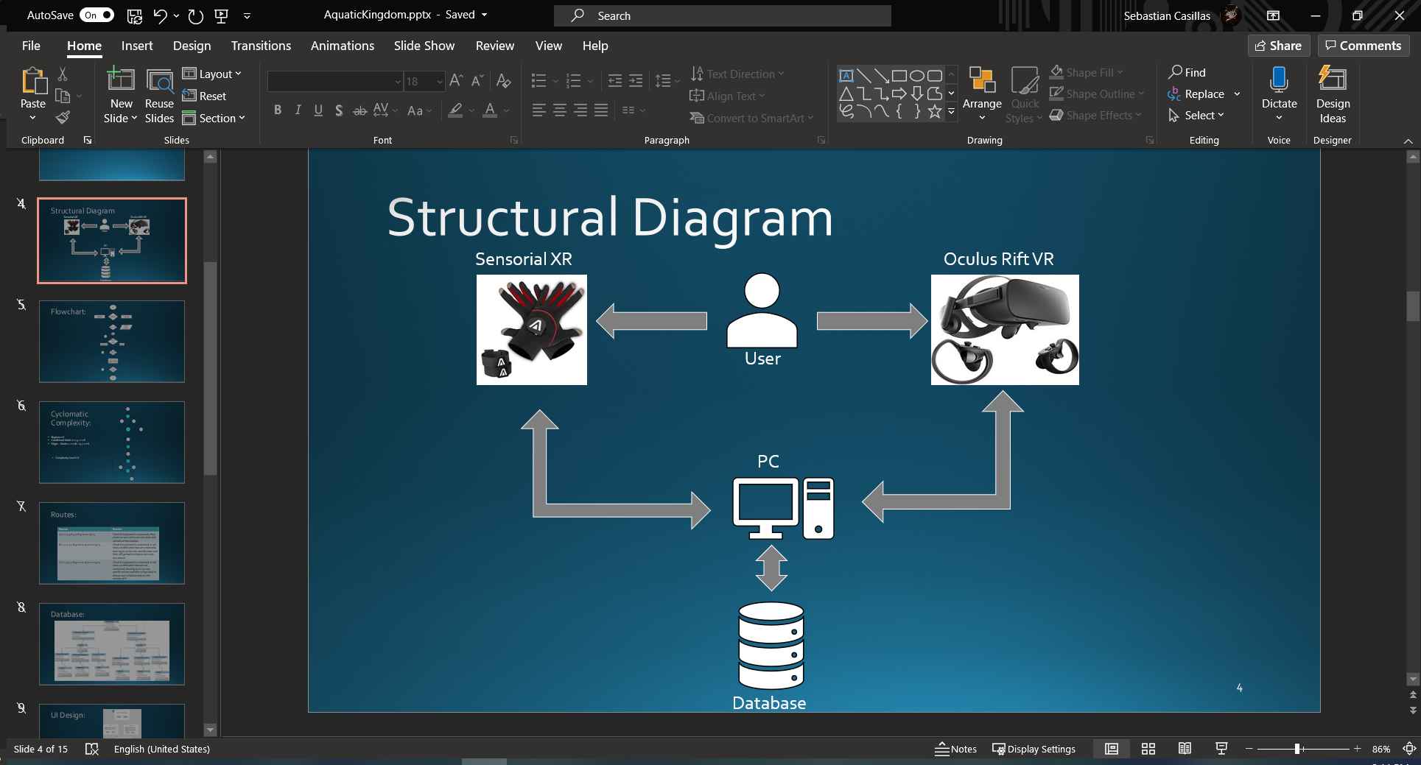

Fig 1. Structural Diagram

This Computer will be connected to a database where the same will be saving some principal information of the user, and in database will be the data of the different environments and the different animals that the software will present. The flowchart of the project it shows since when the VR equipment is connected or not, and it will ask if a new user is or if the user have logged before.

1. FLOWCHART

The Fig. 2 is the flowchart and it shows the different phases where it ask if is a new user and let it register, then goes to the main page where it ask the user if it wants to go to environment or just to see a animal. If it chooses environments, it shows the user different types of environments and each environment have their owns animals. Each animal has their personal information.

­­fig 2. Flowchart

When the user chooses the environment or animal it will ask the user to confirm the choice that it makes. After the user confirm, the output of the software will let the user to be inside the environment with the different animal and per animal it will show the user the information of the own animal, like name, race, type, usual area of living, range of living, etc. Then, when the user ends with that experience, it will ask him if wants to go again or not. If the users want to go again, will send him to the menu to choose between animals or environment again, and repeat the experience. In case the user does not want to repeat the experience, it can exit after the experience is over. The cyclomatic complexity level results to be a 6.

1. CYCLOMATIC COMPLEXITY

In the fig 3, it shows the cyclomatic complexity the way it was simplified to have a lower level. It results to have 18 Edges and 14 Nodes, out of those 14 Nodes there are 5 Conditional ones. The regions counting the outside one, it has a total of 6. That were the complexity level it results to 6.

Fig. 3 Cyclomatic Complexity

Out of all the possible routes that could be done on the cyclomatic complexity, we just use 3. All the routes checks if the equipment is connected, then one of the routes that we selected, it asks the user that if is the first time, that can register on the software. Then it will appear a menu where ask the user which want to go (environment or animal).

Fig. 4. Routes

1. DATABASE DESIGN

The Database design was the simplest that could be done now, this is a very extensive software, and the database could be very complicated design due to how extensive the project could get to be. The design is shown on the fig 5. It shows the environments and different types of animals and plants.

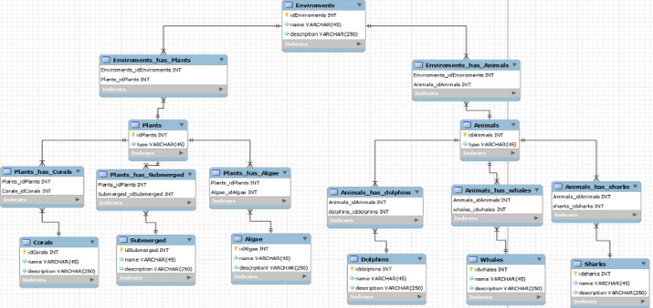

Fig. 5 Database design

1. UI DESIGN

To get this software running user friendly, we must do a UI Design where let the user go on the different phases of the software like it shows on the flowchart. This let the user choose if is new user or have a log. If he is new, it will register the username, email, and password of the new user, and then log in. it shows the menu for environments or animal. This also shows different environment and for each environment there will be some animals with the information and be able to touch the animal while seeing the information. In case that the user only wants to touch one animal at the same time, it can choose in the menu “animal” and shows a list of all the animals available in the software with the information of that animal. After the user had make a choice, it will ask for a confirmation, showing the information he chose and a picture of the environment or animal and when the user confirm, it will start the experience.

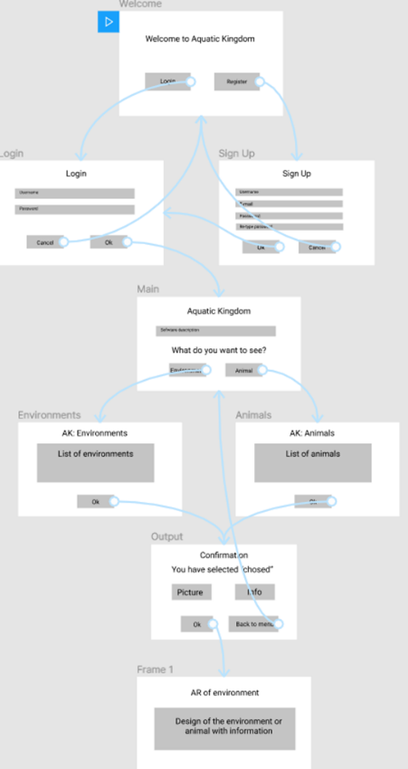

Fig. UI Design

1. WEBPAGE

You might want to know why a web page for this type of project, well for starters this is implemented for the sole purpose of managing the database which is where the VR application will have its information stored. The web page will be done using Spring Framework which provides a comprehensive programing and configuration model for modern Java-based enterprise applications. We use this as base for the webpage and its relatively easy to work with, it allows us to establish JDBC connections using JPA repositories and basic java object-oriented programing and connects our JSP pages to corresponding mappings.

The web page has multiple features configured, first there will be an Admin that can manage everything in the page all the way from the users to the personal information in the database. He can assign that power to selected users which will become employee with their own personal id as well as a user id, this power to employee will be limited to only modify environments or animals or both (as shown in figures 9 and 10). The web page will have a login in which the user will input the information required if not he can create an account to access the web page. The main page will have a summary of what the VR application will be doing and information on the animals that appear on the VR application, ha can click on the animal or environment for more detailed information.

Fig 6. Web Page Initialization

In figure 6 we have the initialization page that allows you to sing in, log in or continue as a guest to the home page. To specify gest and user have the same permissions the do not do anything different and have only access to the animal information and the 3d models. The model in the middle of the page is a 3d animated model, we did NOT create this model or any other that is on the web page, its interactable as you will see later and its generated randomly from the models we have on the database.

Fig 7. Web Page Home

Figure 7 illustrates the home page of the Web App, here you will see the animals that we have in the database and are linked to their respective 3d model when clicked. These boxes will show you the description of each animal, the name, and where they are found. You can also sort out the animals by their race in the first box by clicking one of the races shown. Once any of these animals are clicked (in their name) the user will be taken to the page demonstrated in figure 8 where the model can be interacted with as shown in the instruction above the model, the same applies to the model in figure 6.

Fig 8. Animal Model

Fig 9. Administration Page

Fig 10. Administration Page with selected info

To install this web page on a server the only thing you need to have is the project folder and leave the port 8081 on the server open so that it can receive the request for the webpage through that server. If you are looking to change this, you can enter the project folder and change the port on application properties. After that all you need to do is run the project and remember to do the request with: AnimalKingdom/”path you want to go”.

If you want to modify the paths of request you will have to manually change the desired paths on the project corresponding on what you want.

1. VR MAP

The first map that will contain all the experience of the underwater virtual reality, is at a 50%-60% completed. The user already can move on the environment and through some vegetation and animals already added on the map. The experience the user has, there are some assets added where from there we get the vegetation and some animals where is going to be added information of the same. The next step on this map is to be completed by adding another environment feature and some effects to make the user to feel a better experience.

The Sensorial XR haptics gloves plugins are added on the project already meaning soon the gloves can be used on the map experimenting the feature to feel something in virtual reality. The way the haptics gloves will be activated when needed, is using a hitbox. Depending the hitbox program is how the sensors are going to be activated to let the user have a good experience. Each components and object saved on the database should end with a hitbox where is going to let the map know how and when the gloves will react. In figure 11 we can see that the map is already created with some creatures added. In figure 12, it shows what the user view will be, it will have some diver googles and some effects that make the experience more a real one. In figure 13, we can see that the user will have the diver glasses, and the haptics gloves is already added on the map.

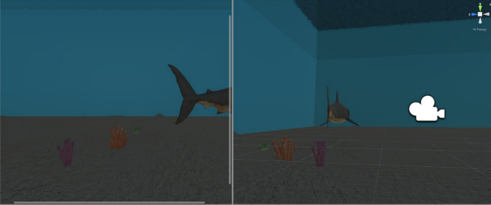

Fig. 11. Map Created

Fig. 12 Preview of what the user would see.

Fig 13. Map with equip added.

The map was completed totally, and every animal let the haptic gloves to activate and make a similar way to feel the animal. There is a stand with a button where let the user interact a let the user to see the information message as shown in the video.

The way to prepare all the equipment first the PC must be on power. Then the software of ND Suite and Oculus must be opened to be able to connect the haptics gloves and glasses. The Oculus Rift VR glasses, the instructions to connect the VR glasses are in the same box are the most detailed as possible. With the gloves, there must be connected on a precise order that the same package have the instructions of the cable order that must be connected. After the cables and the sensors are connected, the user must put the gloves and the sensors in a plane surface where all the sensors should be looking up. After putting the gloves on that position, the user should press the on/off button of the gloves, this will flash in green and blue and that means that the gloves are setting up. Once it starts flashing only blue, means that are ready to connect with the computer. This step needs to be when the user put on the gloves CAREFULLY because the sensors inside the glove are fragile. After the user have the gloves put on, the index finger and the thumb together until the glove starts flashing in cyan blue color, means that the Bluetooth on the gloves is activated. After this go the Bluetooth setting on the computer and connect the gloves as the name the instruction shows. Then go to ND Suite and connect each glove be sure all the sensors are reading correctly. Go to the Flex tab in the ND Suite software and calibrate the thumb sensor as it shows the program. After the gloves are calibrated goes to the Unity Project where the map is available. Then press the play button and after the map is running, press the letter R to calibrate the gloves inside the project and check if the gloves move and activates as it should be. If is not, turn off the gloves and repeat all the process.

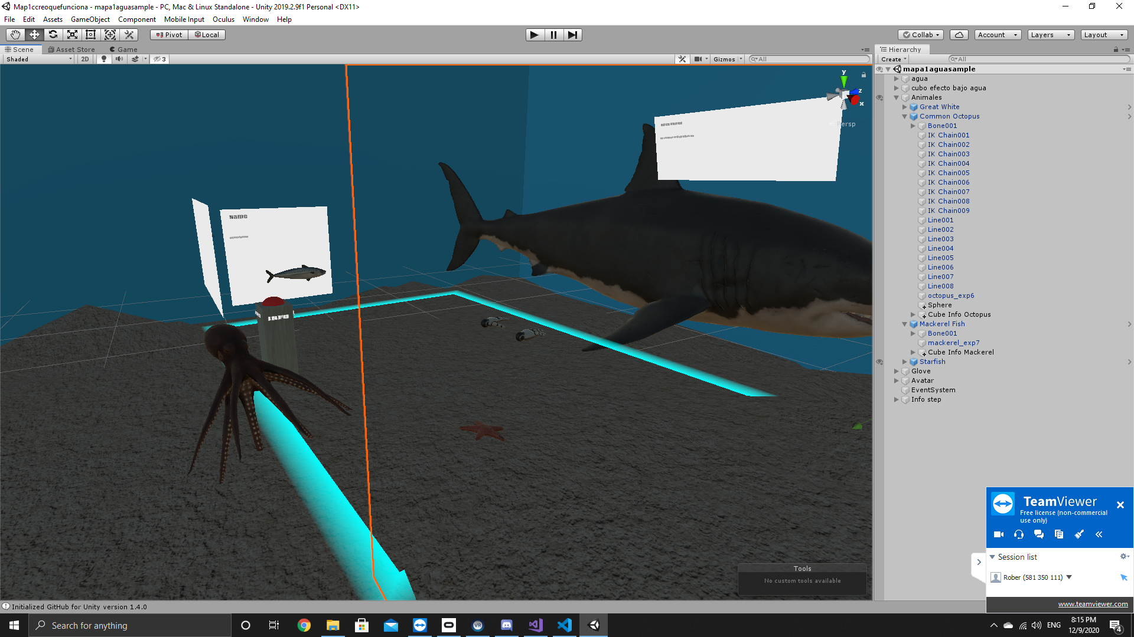

1. CONCLUSION

This is our idea to help those unable to experience this wonderful moment. This project has a lot of development and a lot if future ideas to apply and get it beyond its limits. We hope that this Mixed Reality software help the people of physical disabilities and make even that the normal people get a chance to experience the things of feel the most near to the exact feeling of touching some animals that lives in water.

1. REFERENCES
2. "Home - Sensorial XR", Sensorial XR, 2020. [Online]. Available: https://sensorialxr.com/. [Accessed: 20- Oct- 2020].
3. "Oculus Rift | Oculus", Oculus.com, 2020. [Online]. Available: https://www.oculus.com/rift/. [Accessed: 20- Oct- 2020].